**Week 12 Activity**

**Group Project Task List**

|  |  |  |
| --- | --- | --- |
| Student Name | Student Id | Role |
| Moshe Dayan | 001202300035 | Team Leader |
| Jonathan Ezra Navaro | 001202300100 | Member 1 |
| Hartati Viriya Suryadi | 0012023 | Member 2 |

**Chapter 1. Introduction**

As a group, identify potential problems in your daily life that can be solved using programming.

Example: Restaurant Check-Out Cashier

Then, list potential features that you and your team can develop as a case study (min. 5)

Example:

- Enable user to select multiple drinks

- Enable user to select multiple foods

- Enable user for a re-entry if wrong input is given

- Enable the user to receive the total amount to be paid

- Enable user to pay with 100.000 bills. 50.000 bills,

- Enable user to get balance money in return

**Chapter 2. Flowchart**

Based on the description you provided in Chapter 1, provide the end-to-end flowchart of your program.

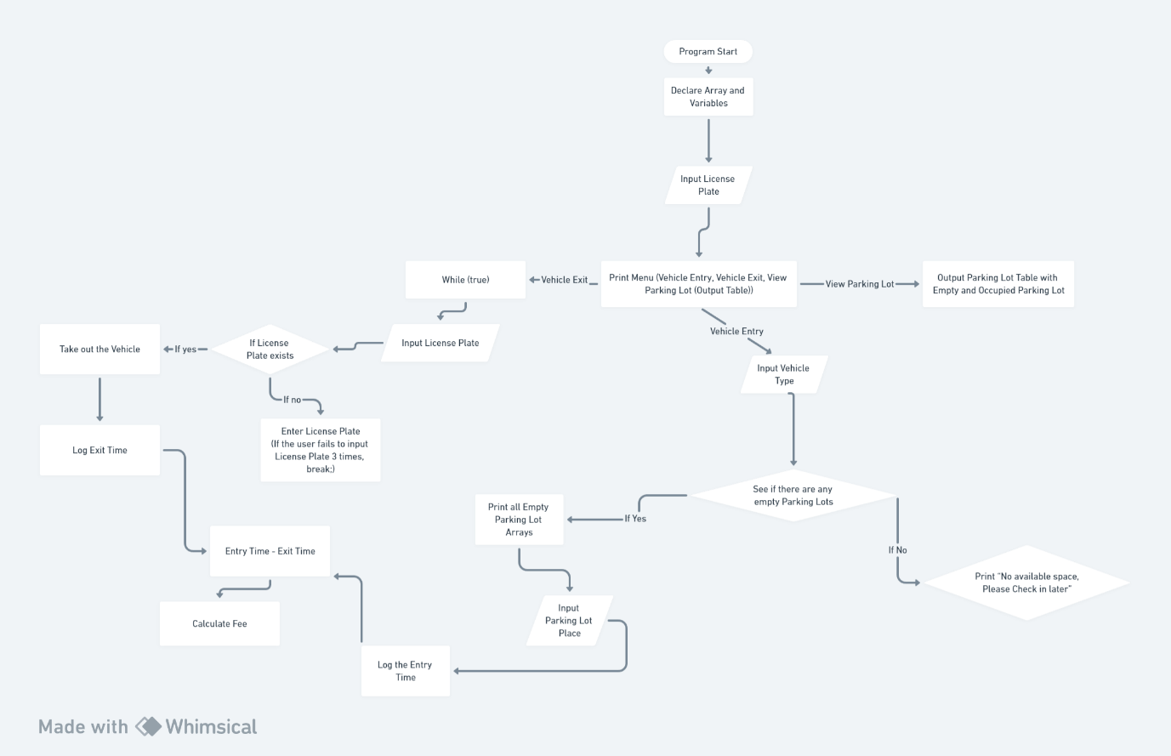

**Chapter 3: The Program**

Provide the program in this section (copy and paste your program here)

|  |  |
| --- | --- |
| Line | Codes |
| 1  2  3  4  5  6  7  8  9  10  11  12  13  14  15  16  17  18  19  20  21  22  23  24  25  26  27  28  29  30  31  32  33  34  35  36  37  38  39  40  41  42  43  44  45  46  47  48  49  50  51  52  53  54  55  56  57  58  59  60  61  62  63  64  65  66  67  68  69  70  71  72  73  74  75  76  77  78  79  80  81  82  83  84  85  86  87  88  89  90  91  92  93  94  95  96  97  98  99  100  101  102  103  104  105  106  107  108  109  110  111  112  113  114  115  116  117  118  119  120  121  122  123  124  125  126  127  128  129  130  131  132  133  134  135  136  137  138  139  140  141  142  143  144  145  146  147  148  149  150  151  152  153  154  155  156 | import java.util.Scanner;  public class App {      public static void main(String[] args) throws Exception {          Scanner input = new Scanner(System.in);          int[] LicensePlate = new int[10];          int[] parkingSpace = { 0, 0, 0, 0, 0, 0, 0, 0, 0, 0 };          int[] entryTime = new int[10];          int[] exitTime = new int[10];          int vehicleType;          int park;          int i = 0;          boolean statement = true;          boolean intro = true;          while (statement) {              System.out.println("Enter your Vehicle Type : ");              System.out.println("1. Motorcycle");              System.out.println("2. Car");              vehicleType = input.nextInt();              System.out.println("Enter your License Plate : (Combination of 1 Variable and 3 Integer)");              System.out.println("For example : (1234)");              LicensePlate[i] = input.nextInt();              System.out.println("How can we help ?");              System.out.println("1. Vehicle Entry");              System.out.println("2. Vehicle Exit");              System.out.println("3. View Parking Lot");              int choice = input.nextInt();              if (choice < 1 && choice > 3) {                  continue;              } else {                  int indexPark = 0;                  if (choice == 1) {                      boolean a = true;                      while (a) {                          if (vehicleType < 1 && vehicleType > 2) {                              System.out.println("Please enter valid Input!");                              continue;                          } else {                              a = false;                              for (int j = 0; j < parkingSpace.length; j++) {                                  if (parkingSpace[j] == 0) {                                      System.out.println("Parking Space Available!");                                      for (int x = 0; x < parkingSpace.length; x++) {                                          if (parkingSpace[x] == 0) {                                              for (int t = 0; t < parkingSpace.length; t++) {                                                  if (parkingSpace[t] == 0) {                                                      System.out                                                              .println("Parking Space in Number " + t + " is available");                                                  } else {                                                      System.out.println(                                                              "Parking Space in number " + t + " is not available");                                                  }                                              }                                              System.out.println("Please choose where to park. ");                                              park = input.nextInt();                                              if (parkingSpace[park] == 0) {                                                  parkingSpace[park] = 1;                                                  indexPark = park;                                                  System.out.println("You have successfully parked! ");                                                  System.out.println("Input entry time : (In Hours)");                                                  entryTime[park] = input.nextInt();                                                  i++;                                                  a = false;                                                  x = parkingSpace.length + 1;                                                  j = parkingSpace.length + 1;                                              }                                          }                                      }                                  } else {                                      System.out.println("No parking space available, please come back later! ");                                      break;                                  }                              }                          }                      }                  } else if (choice == 2) {                      boolean exit = true;                      int counter = 0;                      int what = i - 1;                      while (exit) {                          System.out.println("Please enter your License plate : ");                          int licenseCheck = input.nextInt();                          if (licenseCheck == LicensePlate[what]) {                              parkingSpace[indexPark] = 0;                              System.out.println("Input exit time : (In Hours)");                              exitTime[indexPark] = input.nextInt();                              if (vehicleType < 0 && vehicleType > 1) {                                  continue;                              } else if (vehicleType == 1) {                                  int motorTime = entryTime[indexPark] - exitTime[indexPark];                                  System.out.println("Your cost will be " + (motorTime * 2500));                                  exit = false;                              } else {                                  int carTime = entryTime[indexPark] - exitTime[indexPark];                                  System.out.println("Your cost will be " + (carTime * 5000));                                  exit = false;                              }                          } else {                              System.out.println("You have failed for " + counter + " times.");                              counter++;                              if (counter == 5) {                                  System.out                                          .println("You have failed too many times, you can not exit your vehicle.");                                  break;                              }                          }                      }                  } else {                      for (int y = 0; y < parkingSpace.length; y++) {                          if (parkingSpace[y] == 0) {                              System.out.println("Empty Space at " + y);                          } else {                              System.out.println("There is an occupied parking space at " + y);                          }                      }                  }              }          }      }  } |

[Full Code See Here](https://github.com/xympyo/programmingConceptGroupProject/blob/main/src/App.java)

**Chapter 4: The Screenshot**

Give a screenshot of your feature here. Each screenshot should represent 1 feature, as listed in Chapter 1.

1. 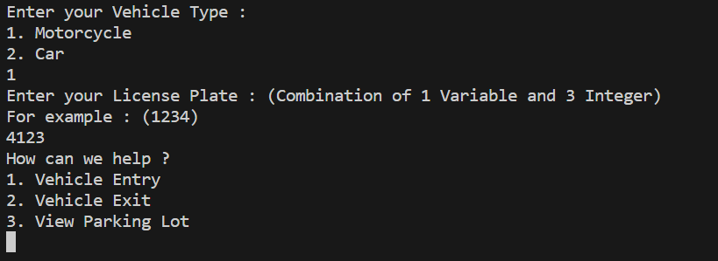  
   User able to determine their Vehicle Type, their License Plate and to choose what to do
2. 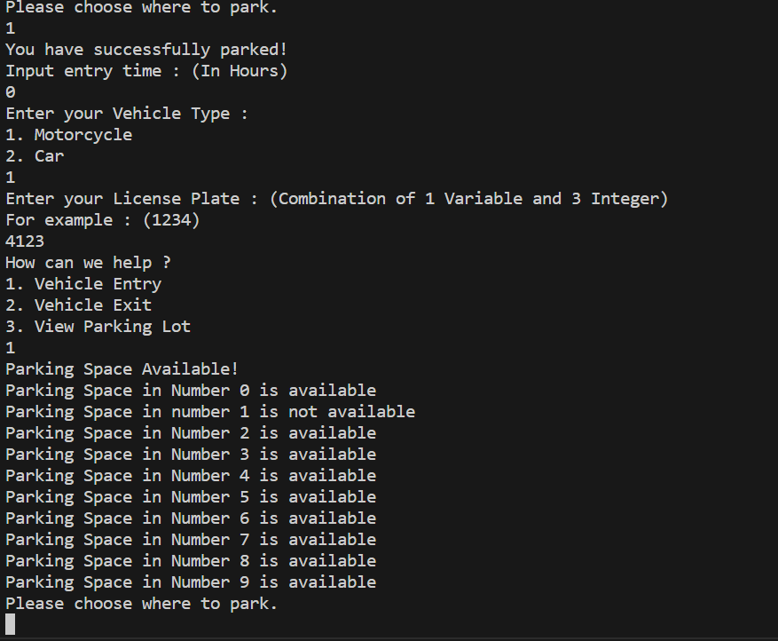  
   User able to know which parking lot is empty or not
3. 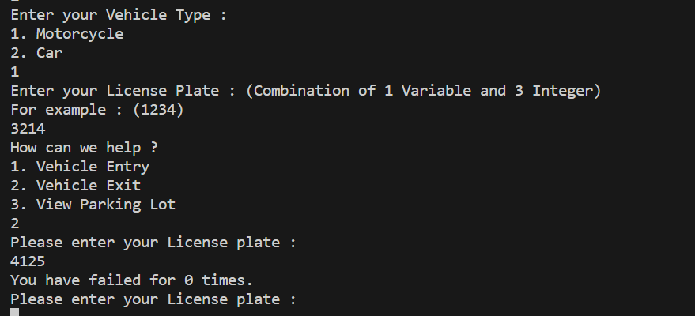  
   User able to Take out their Vehicle in the try of 5 times, ensuring Security.
4. 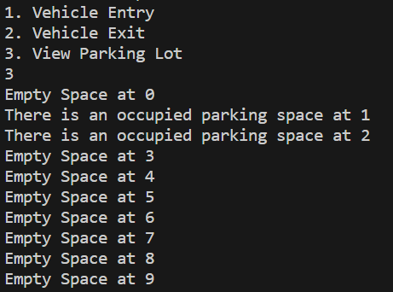  
   User able to view which parking lot are available.
5. 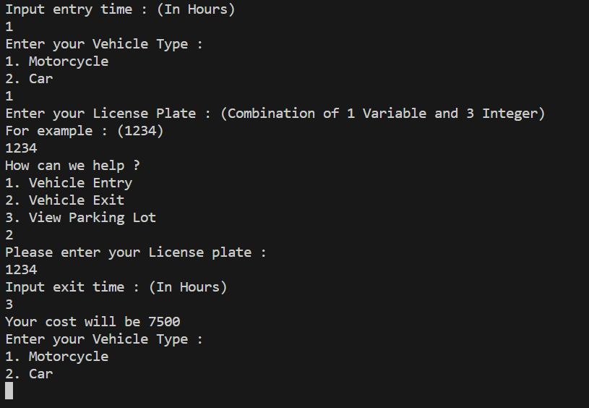  
   User will able to get the cost of their Parking time.

**Chapter 5: Requirement checks**

|  |  |  |
| --- | --- | --- |
| **No** | **Requirements** | **Yes/No, Line No X - Y** |
| **1** | **Have at least one if / if-else and one nested if-else** | **Yes, in line number 44-67.** |
| **2** | **Have at least one while and one nested while** | **Yes, in line number 34-75.** |
| **3** | **Have at least one 1 Dimensional Array** | **Yes, in line number 6-9.** |
| **4** | **Have at least one mathematical operator calculation** | **Yes, in line 91 and line 95** |
| **5** | **Have at least one Boolean expression** | **Yes, in line 13,14,15 and 80** |

**Chapter 6: Log Hours**

|  |  |  |
| --- | --- | --- |
| Student Name | Activity | Log Hours |
| Moshe | Coding  Documentation  Flowchart | 2 hours  30 minutes |
| Jonathan | Flowchart  Documentation | 1.30 hours 30 minutes |
| Viriya | Flowchart  Documentation | 1.30 hours 30 minutes |